Contact Manager Application

* Description

This program allows you to make your contact list, with the ability to :

* Adding new users.
* Editing an existing user.
* Showing the number of users in your list.
* Searching for a user by one of its attributes.
* Deleting a user.
* Making a report file to save your changes in a .txt file.

# Classes Diagram

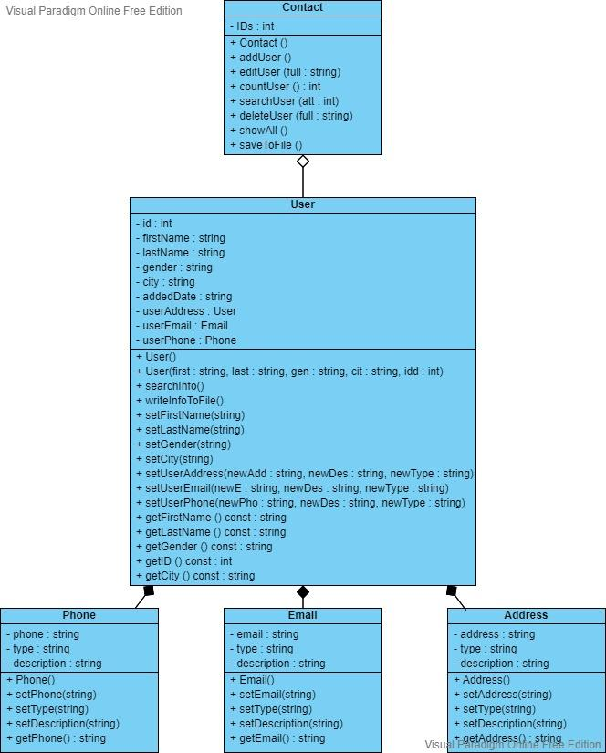

# Basic Data Structure

* + The program is based on “map” structure :
    - Key : full name.
    - Value : from the “User” type, which has all the user’s information.
    - Plus I can add, edit, count, search and delete easily :)

# C++ Code

https://drive.google.com/file/d/1aWr4XKUmlx8MOMSDkpBGtZR231ZcwkKA/view?usp=sharing

# Snippets For the Execution

* + The home page :   
    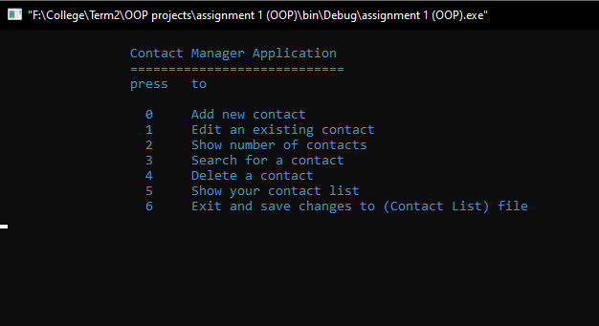
  + Adding new user :   
    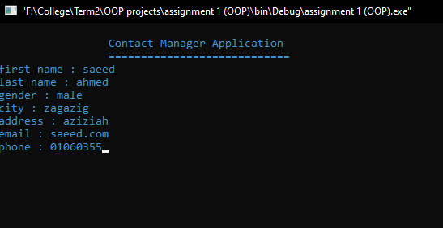
  + Editing user’s information :   
    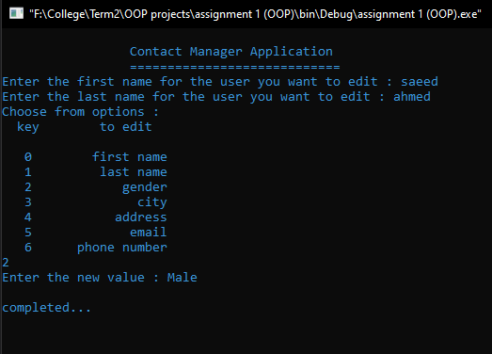
  + Show number of users in your list :   
    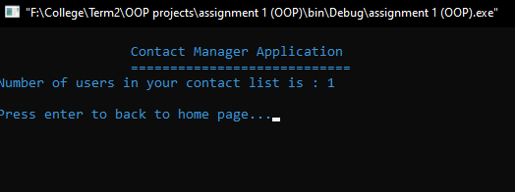
  + Search for user using one of its attributes (id, name, gender, city) :  
    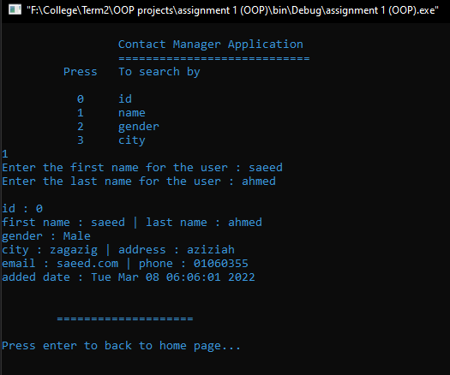
  + Delete a user :   
    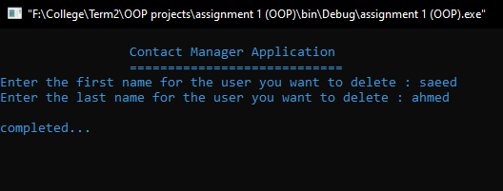
  + Show contact list :   
    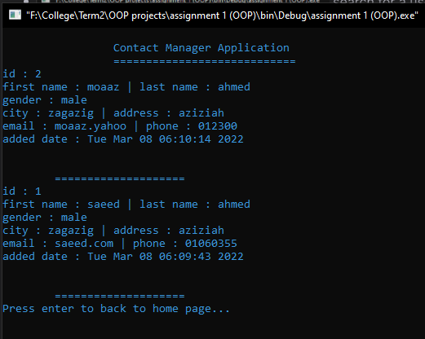
  + Exit and saving your changes to (Contact List) file :   
    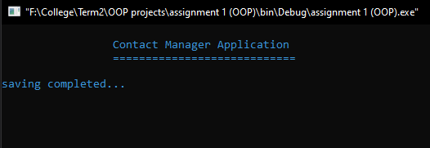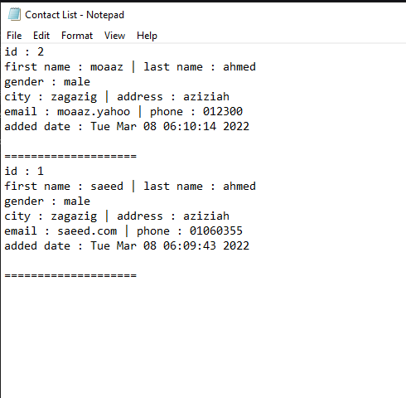

By : **Saeed Ahmed Khadra**

Section : **12**